**PLEASE ANSWER ALL QUESTIONS. Total 25 Marks**

**QUESTION 1**

What are the different datatypes used for transmitting data? “XML must have one root key-value pair. JSON can have multiple.” Explain with an example. **(3+4=7 Marks)**

**QUESTION 2**

What are the different types of data you can transmit using routes in flask? How do you use dynamic elements in a Jinja template? Provide an example.

Consider the following python route:

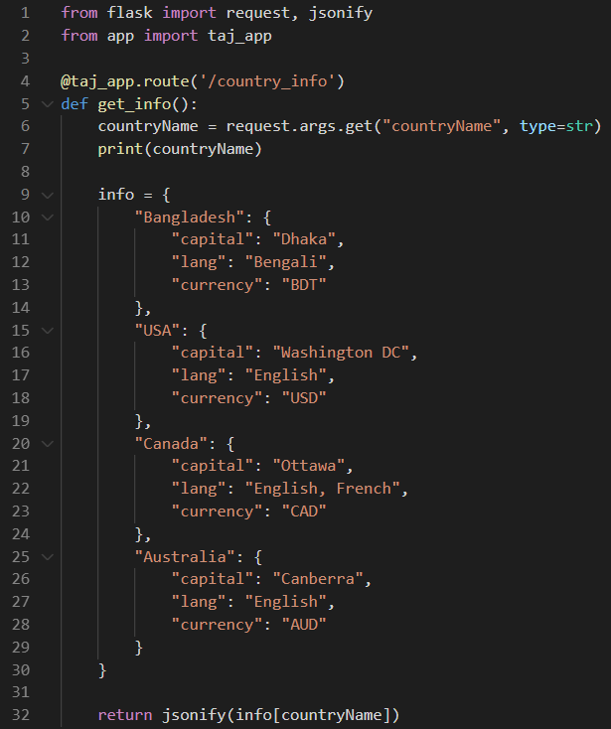

Now look at the results displayed when this route is called:

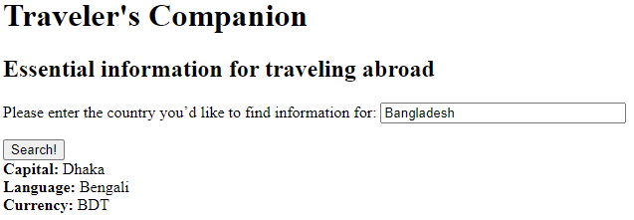

Write the code to display the Capital, Language and the Currency of the searched country. Use the flask templating syntax to display the information. **(2+3+3=7 Marks)**

**QUESTION 3**

Write a program (HTML and Javascript) with a button that counts the number of times it has been clicked and displays the result in a div. Instead of using Javascript DOM objects, use jQuery to perform the operation. **(5 Marks)**

**QUESTION 4**

Briefly discuss the steps of SSL encryption and how it prevents unauthenticated access to protected resources. **(3+2=5 Marks)**

**\*\*END OF QUESTIONS\*\***